Base Kirby Creation

The base Kirby is a very important step in the process of creating all the Kirby variants. With it we can derive all the variants. In this first section we will be presenting the creation of the base Kirby, that will be later used for the variants. First, we start with a simple sphere 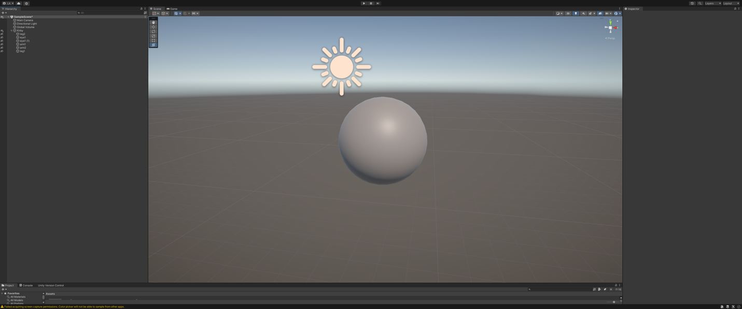

Now we add the eyes 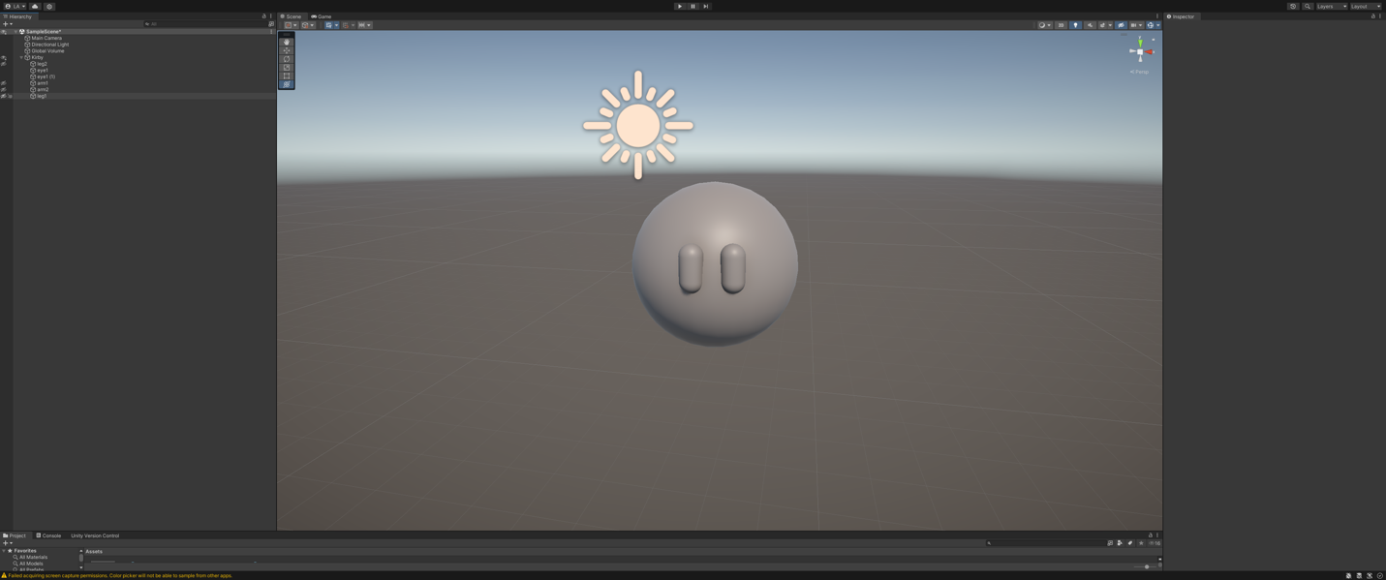

Add arms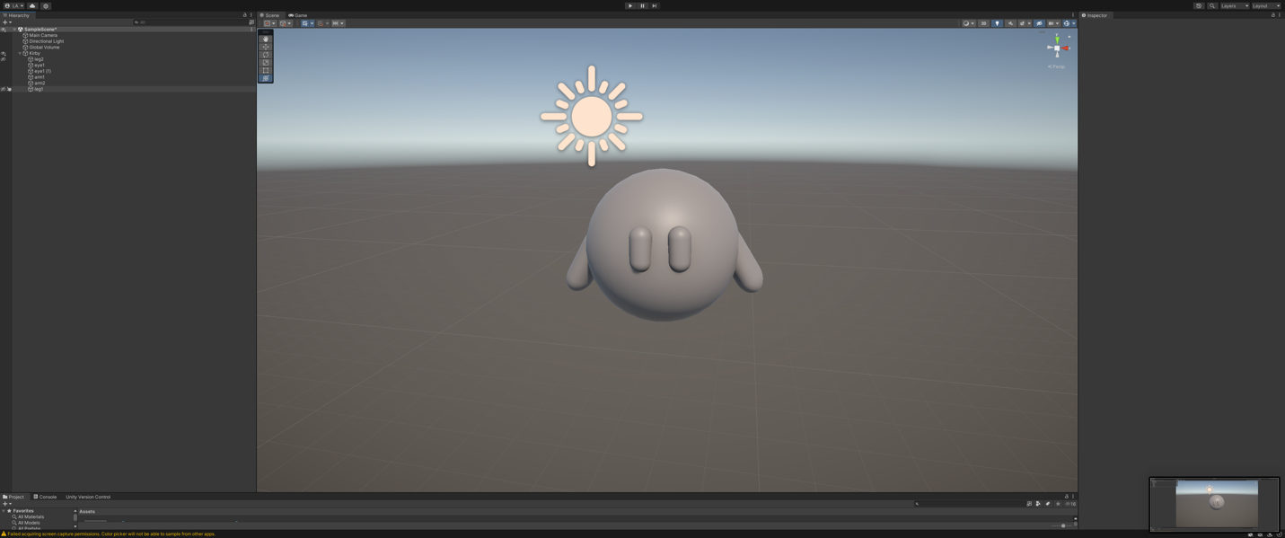Add feet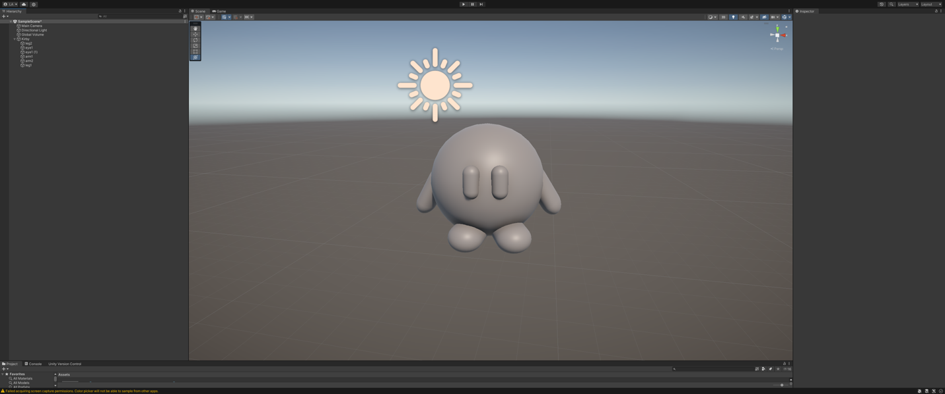

Create object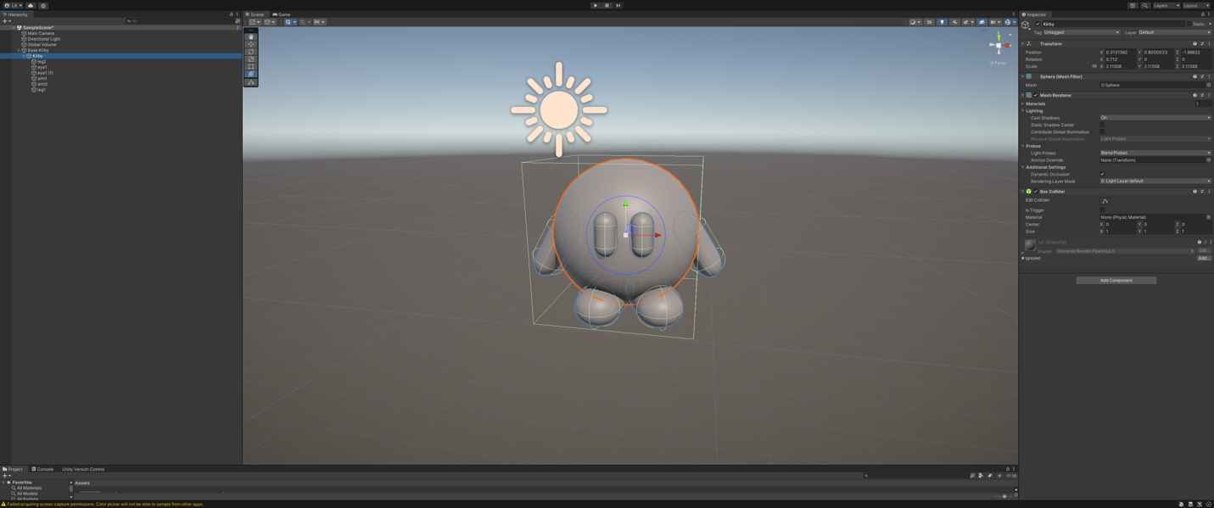

Create prefab

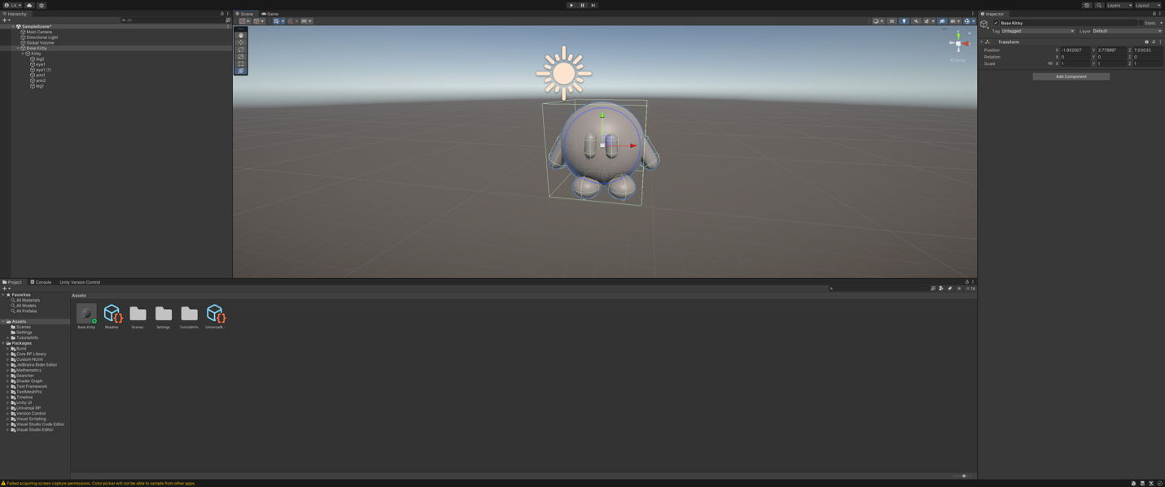

Add color

Now we have the base Kirby prefab, we would like to add some color to it. This would make more appealing and adds life into the Kirby and its variants. To do this we would first create a new folder in our assets folder, called “Color”.

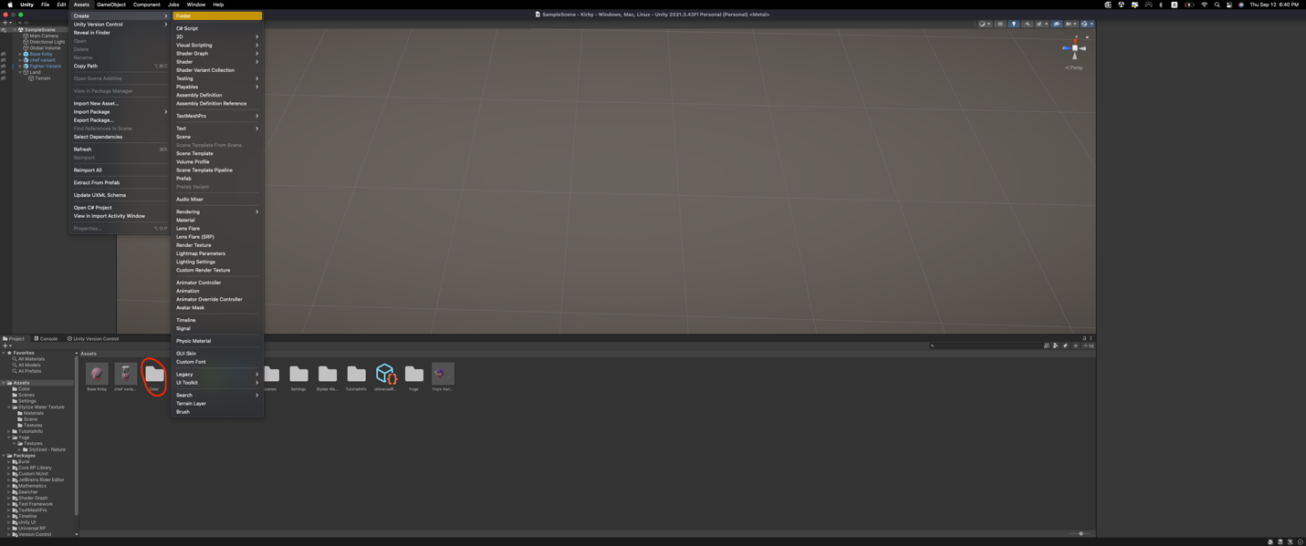

Next, we create a new material in the color folder and change the color to resemble the colors of Kirby. In the example image we created an example color.

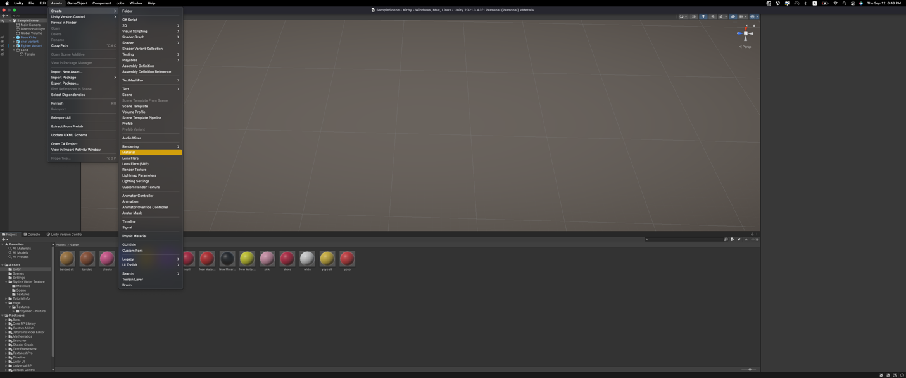

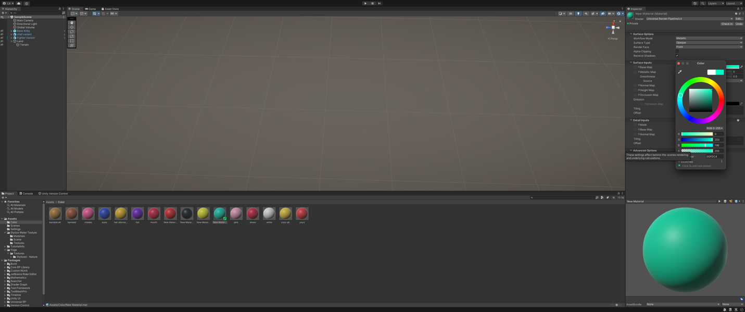

When we have the color folder with all the colors we need, we can click and drag the color to the section we want to color. The first image represents all the colors in the color folder, the rest of the images take us through how to add color. We first select the color and we drag and drop it to the area we want to color.

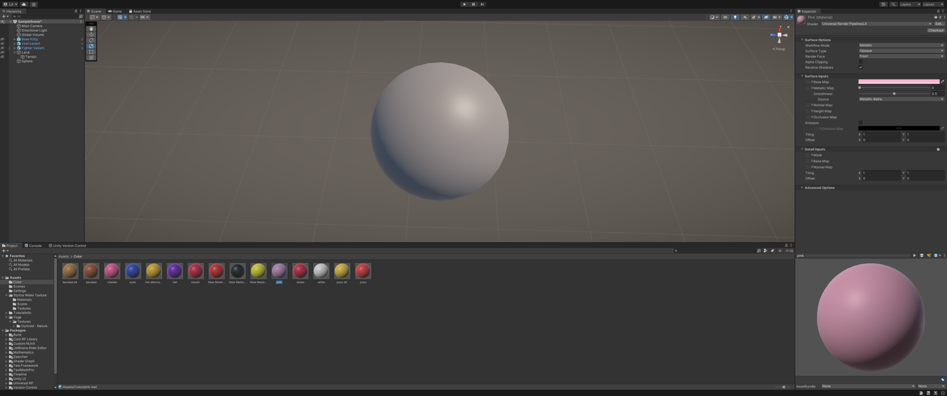

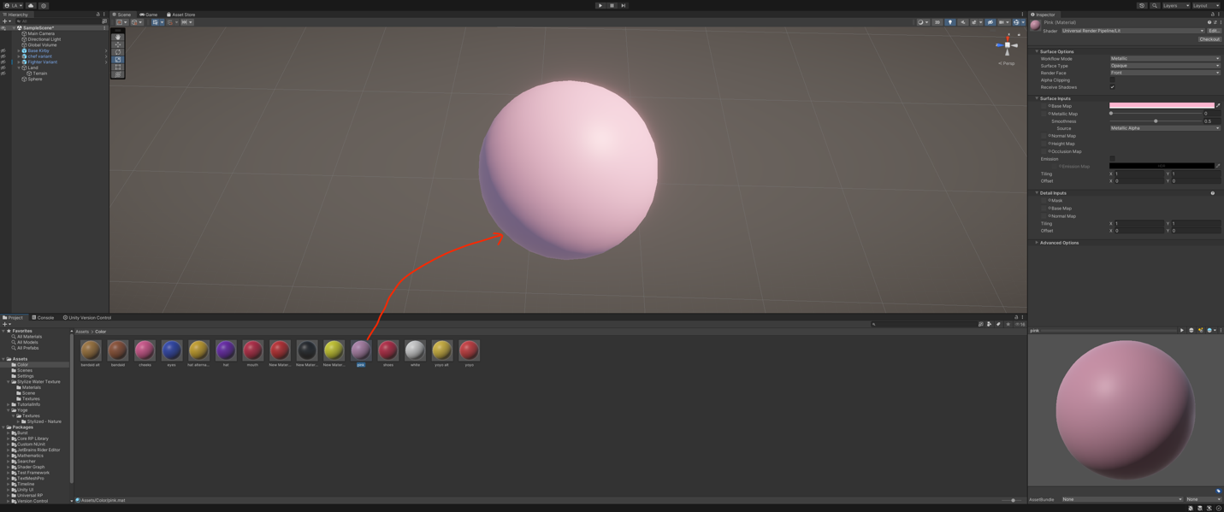

Variant Creation

Now that we have a colored prefab of the Kirby, we would proceed to create a Prefab Variant and edit it to resemble the Kirby variant we want. We can select this prefab and create a prefab variant, by right clicking on the prefab, selecting create and then click Prefab Varian.

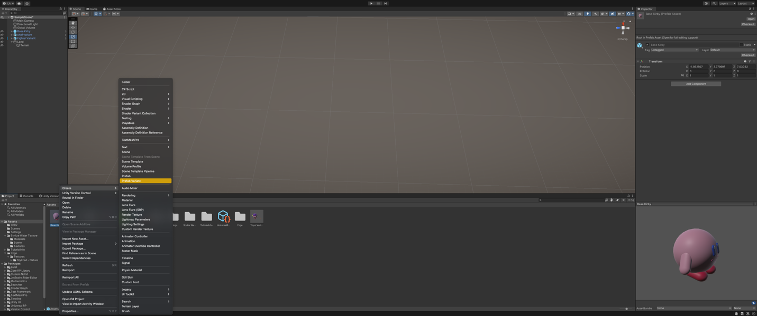

When we create the prefab variant, we can edit it and create the Kirby variants, this is an example of one of the variants created using the Base Kirby Prefab. All other variants are created in the same way.

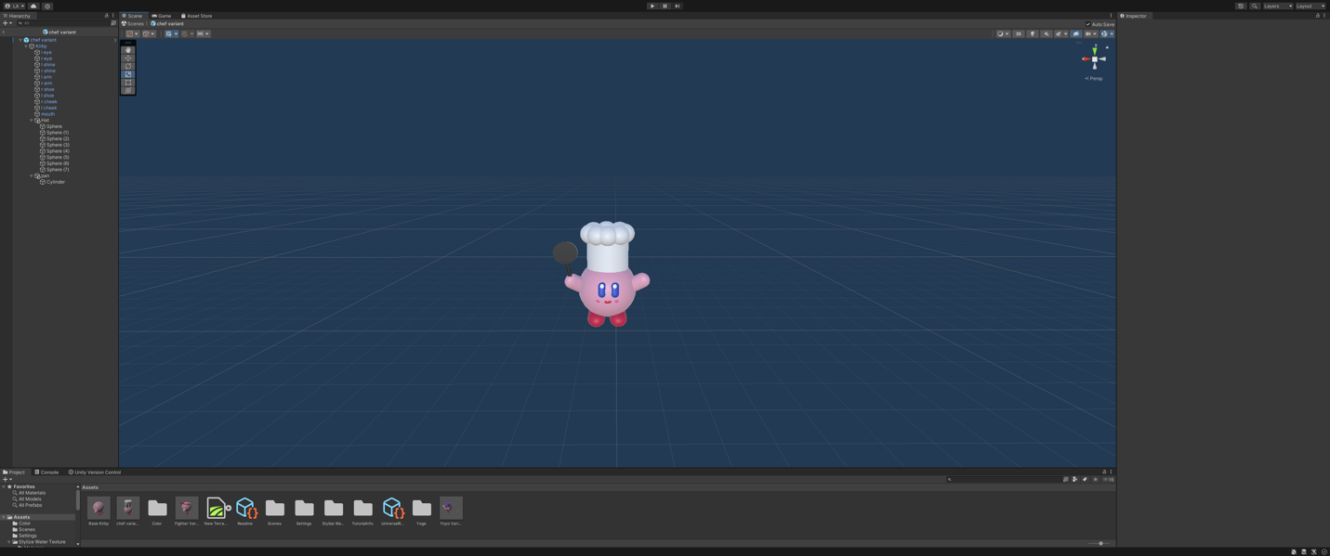

Terrain creation

To start with the creatin of the terrain we first need to create an empty object, that we called “Land”.

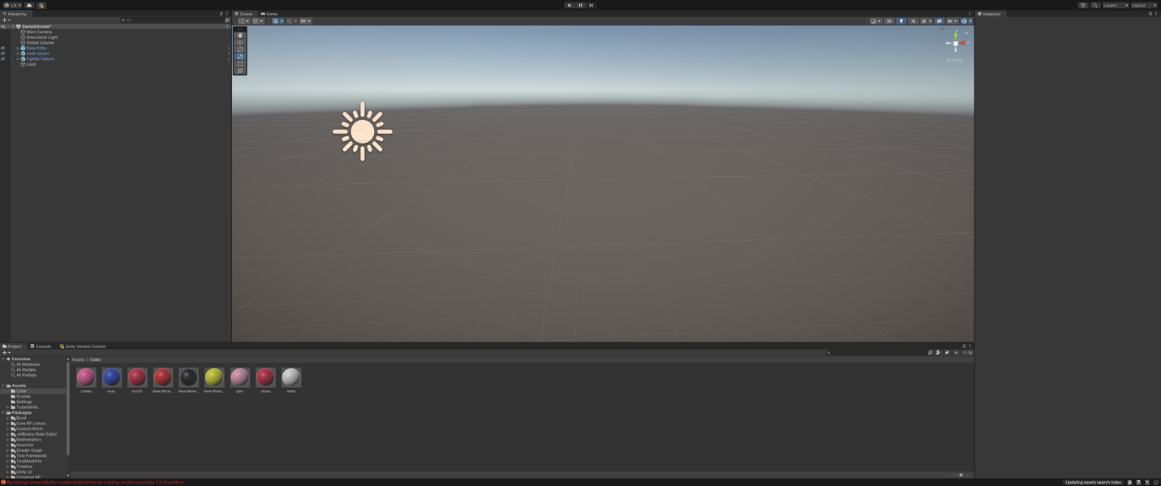

In this empty object we create are terrain by right clicking on the side panel and select 3D object and then terrain.

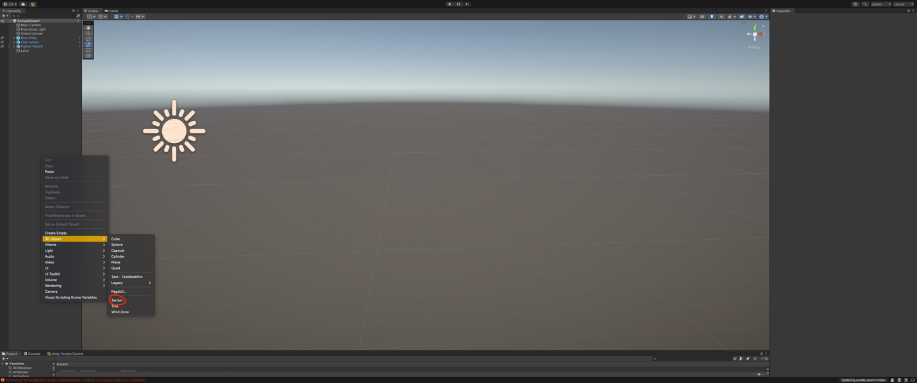

Now that we have created our terrain, we set the dimensions of the terrain.

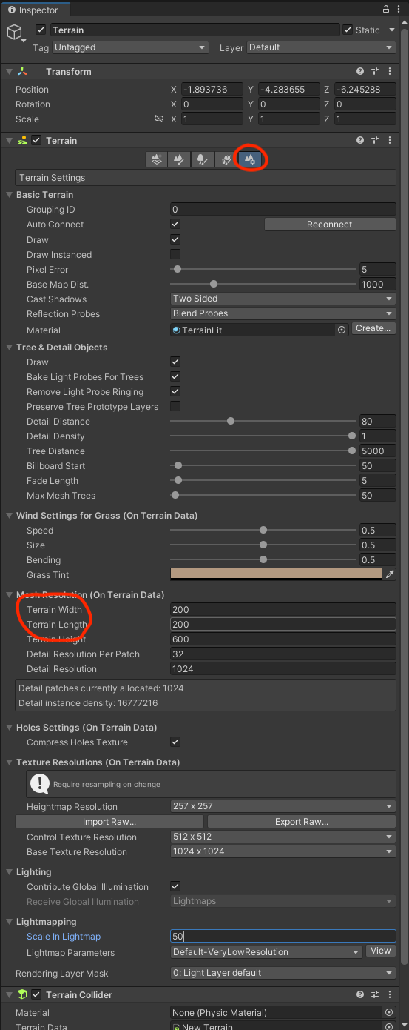

We then set the height in the “Set Height” section.

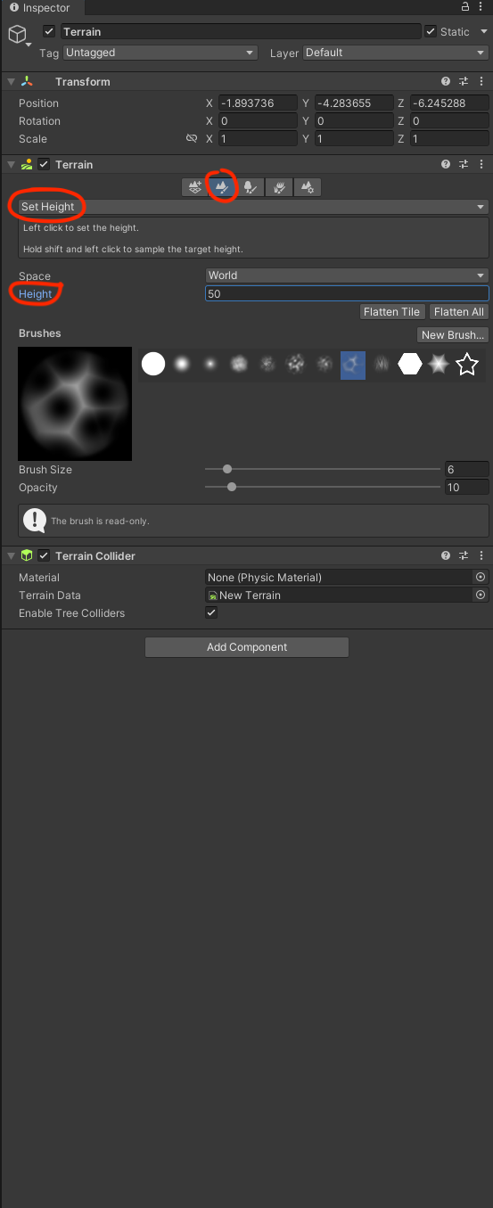

Then we can go the “Raise or Lower Terrain” section. With this if we hold left click, we raise the terrain, creating hills and mountains, and if we hold shift and then left click we can lower the terrain, creating rivers and lakes.

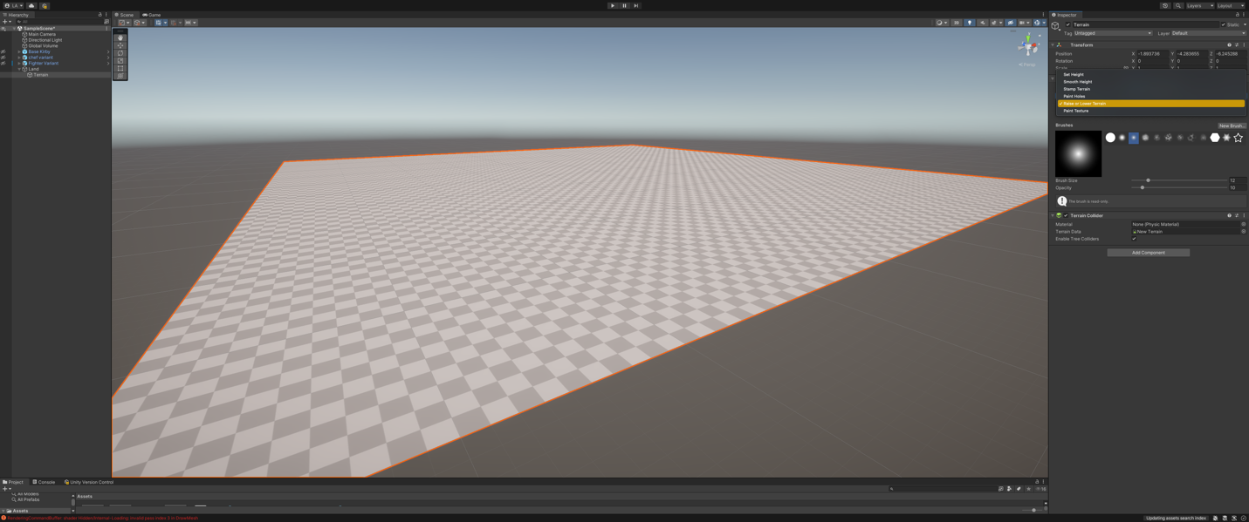

The next step is to choose a part of the map of Puerto Rico to recreate for our map.

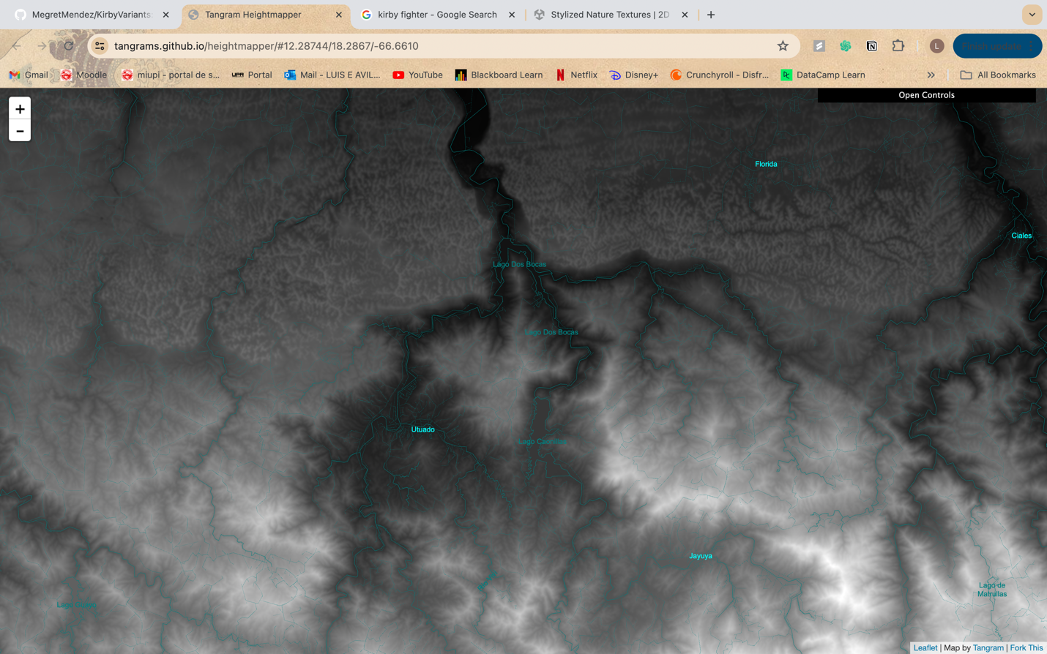

When we have the section of the map, we want we proceed to recreate it using the “Raise or Lower Terrain” tool. Remember that left click raises the terrain and shift + left click lowers the terrain.

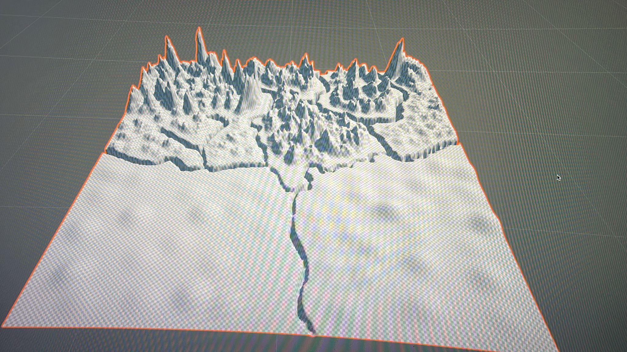

Now we have created our terrain, we can now proceed to add some textures to our map. This helps give it more color and adds life to the map. We do this by first going to the asset store, this is shown in the image bellow. 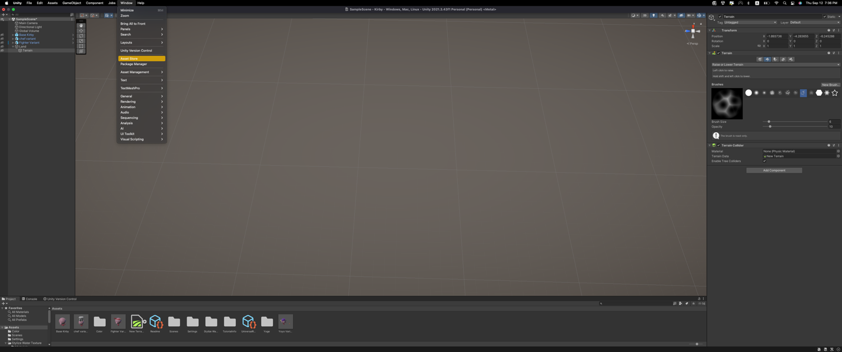

When we go into the asset store we can then proceed to search for a texture pack we want. When we have it we click “Add to My Assets” and it will be added to the Unity account. We selected two assets, the first one add water texture for the rivers and the second one add different styles of terrains.

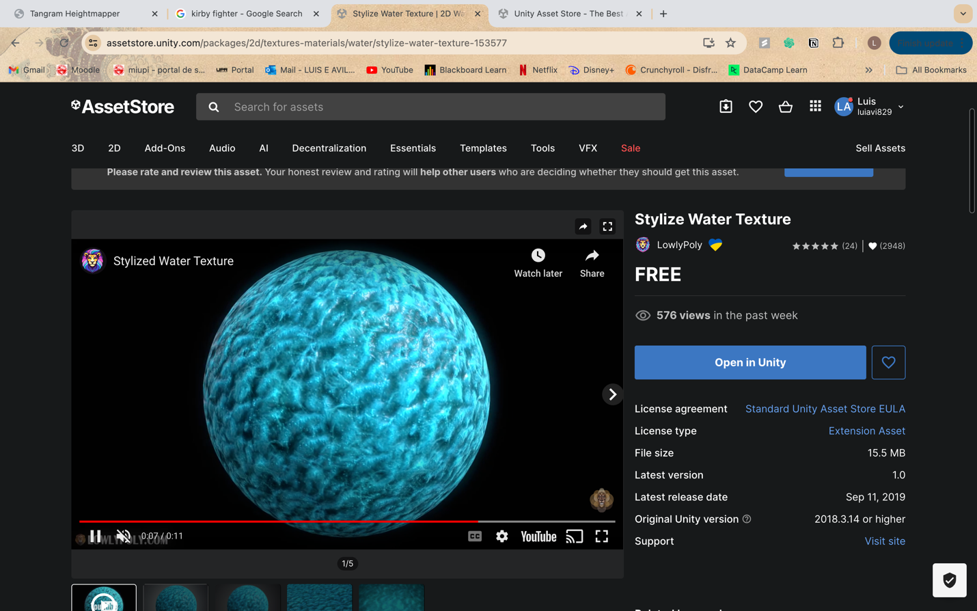

NOTE: In this case we don’t see the “Add to my Assets” button this is because it is already added.

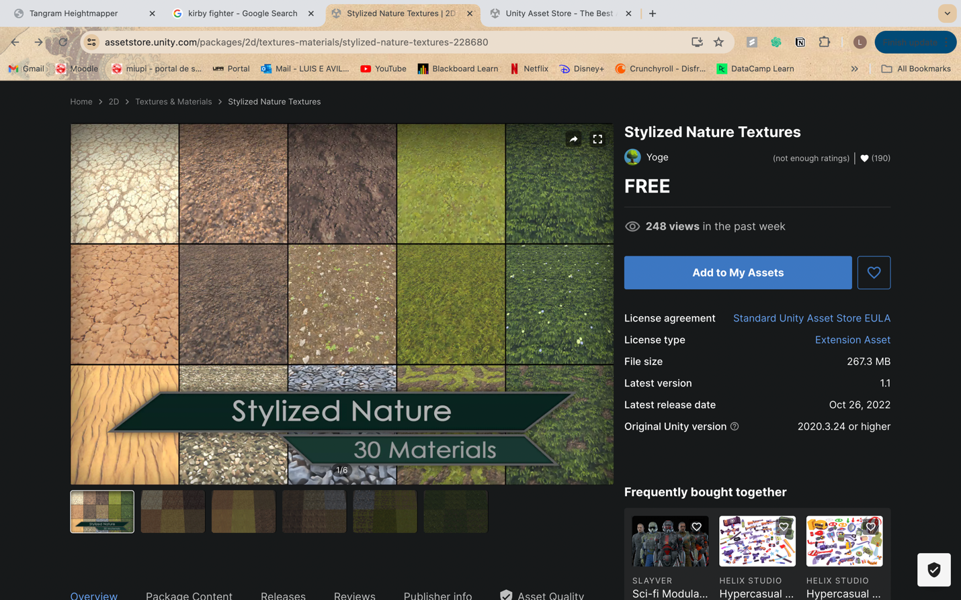

When we have them in the Unity, we download them and import them. Now that we have the texture, we proceed with adding the texture to the map. To do this we go to the “Pain Terrain” section. Here we select the “Edit Terrain Layers…” button.

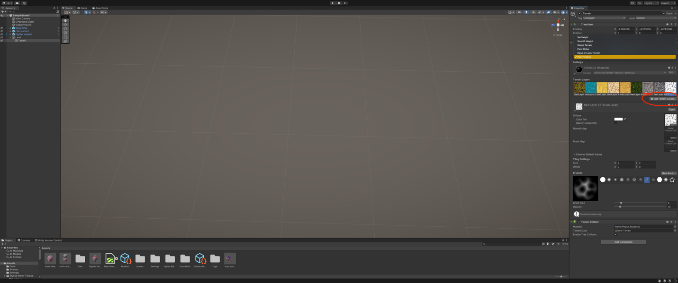

Then we click the “Create Layer” button, and menu appear and here we select the terrain we want by double clicking it. It would then be added to “Terrain Layers”. To use the we can select the one we want and use the Brushed to paint with them.

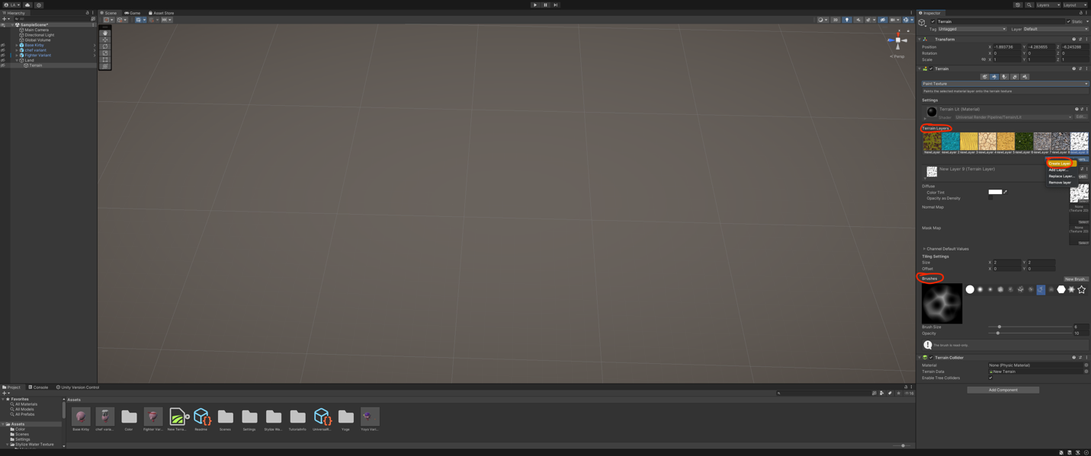

FINAL PICTURE

